**TNT TECHNOLOGY STORE**

**TNT GROUP MEMBERS:**

* TNT: Tran Trung Thanh – JAS22079
* TNT: Huynh Nguyen Tan Nhac – JAS22084
* TNT: Tran Vu Thien – JAS22085

**CONTENTS**

**1.** **Introduction:** 1

**2.** **Objective:** 1

**3.** **Scope:** 1

**4.** **Signification:** 1

**5.** **Modules:** 2

**Login-Signup Module:** 2

**Profile-Detail Module:** 2

**Product Module:** 2

**Single Product Module:** 2

**Cart Module:** 2

**Dashboard Module:** 2

**Order Module:** 2

**Order Detail Module:** 2

**6.** **User Interface Design:** 2

**7.** **Technologies Used:** 3

**Front End:** 3

**HTML:** 3

**CSS:** 3

**JavaScript:** 4

**TypeScript:** 4

**Back End:** 4

**Java:** 4

**Spring Boot:** 4

**Spring Data JPA:** 4

**Spring Security JWT:** 5

**Database:** 5

**Oracle SQL:** 5

**8.** **Hardware Requirements:** 5

**9.** **Project Life Cycle:** 6

**Agile Software Development Methodology:** 6

**Phases of Agile Methodology:** 6

**10.** **Snapshots:** 7

**11. Use Case Model:** 15

**12. Data Flow Diagram** 21

**13. Use Case Diagram** 22

# **Introduction:**

In industry 4.0, with the outstanding development of science and technology, the field of information technology and e-commerce has been playing an extremely important role for the current economy. Information technology and e-commerce have been present in most areas of life and have become a very effective support tool in management and business.

E-commerce brings a lot of benefits to both businesses and consumers, helping to save time and costs of management, shopping and consumption. At the same time, today, people's need to use electronic devices is becoming more and more high. Applying information technology and e-commerce to help sellers easily manage their devices and easily choose suitable electronic products for buyers, our team decided to choose the topic: "Building a website to sell electronic products such as technology product".

# **Objective:**

* Create an e-commerce website, control by individual which can show product, categories, login, register, create, update, delete product.
* Help customers/users who can reach in website can easy to order product on it.

# **Scope:**

Our project aims to convenient and easy to buy technology products

1. It satisfies the user.

2. It is easy to buy technology products

3. It is easy to operate.

4. Have a good user interface.

5. It saves time and functions faster.

6. It helps the admin to insert a technology products.

We developed safe and secure software with above mentioned specifications.

# **Signification:**

* Everyone reach in this website can easy see product and planning for order items, it is help them for order from home.
* User can easy to update their information.
* Orders and Selling Process becomes faster.
* Access technology products information easily.
* Decrease the time of travelling by access the website
* Have a dashboard for Admin.
* Easy & fast retrieval of information.
* Providing better storage capacity.
* Creating and changing data at ease.

# **Modules:**

## **Login-Signup Module:**

The system allows both users and administrators to log in.

The users have limited access to the website, admin have full access to the website.

And about the signup module only users are allowed to register new accounts, and each administrative account will be granted separately.

## **Profile-Detail Module:**

The system allows users to see their profile and they can update their profile’s information

## **Product Module:**

In this module, the user/customer can easily view products, products of categories

## **Single Product Module:**

In this module, the user/customer can easily view detail of a product, quantity

## **Cart Module:**

In this module, the user/customer can add any technology stuff to cart quickly and conveniently. Besides, the user can order or delete the cart.

## **Dashboard Module:**

In this module admin can add new products easily, edit product’s information

## **Order Module:**

In this module, users can easily view their order history

## **Order Detail Module:**

In this module, users can view the detail of order, products in an order, price, quantity

# **User Interface Design:**

User interface (UI) design or user interface engineering is the design of user interfaces for machines and software, such as computers, home appliances, mobile devices, and other electronic devices, with the focus on maximizing usability and the user experience. In computer or software design, user interface (UI) design primarily focuses on information architecture. It is the process of building interfaces that clearly communicates to the user what's important. UI design refers to graphical user interfaces and other forms of interface design. The goal of user interface design is to make the user's interaction as simple and efficient as possible, in terms of accomplishing user goals.

The following steps are various guidelines for User Interface Design:

* Make buttons and other common elements perform predictably so users can unconsciously use them everywhere. Form should follow function.
* Keep interfaces simple (with only elements that help serve users’ purposes)
* Minimize the number of actions for performing tasks but focus on one chief function per page.
* Put controls near objects that users want to control. For example, a button to submit a form should be near the form.
* Use appropriate UI design patterns to help guide users and reduce burdens (e.g., pre-fill forms)
* Some code in client (FE) and server(BE) that don't have enough time to implements but the website still have enough to say as an e-commerce website.

# **Technologies Used:**

## **Front End:**

**Angular:**

Angular is an open-source, JavaScript framework written in TypeScript. Google maintains it, and its primary purpose is to develop single-page applications. As a framework, Angular has clear advantages while also providing a standard structure for developers to work with. It enables users to create large applications in a maintainable manner.

### **HTML:**

HTML (Hypertext Markup Language) is the code that is used to structure a web page and its content. For example, content could be structured within a set of paragraphs, a list of bulleted points, or using images and data tables.

### **CSS:**

Stands for “Cascading Style Sheet”. Cascading style sheets are used to format the layout of Web pages. They can be used to define text styles, table sizes, and other aspects of Web pages that previously could only be defined in a page’s HTML.

### **JavaScript:**

JavaScript is a lightweight programming language that web developers commonly use to create more dynamic interactions when developing web pages, applications, servers, and or even games.

### **TypeScript:**

TypeScript is a strongly typed, object oriented, compiled language. It was designed by **Anders Hejlsberg** (designer of C#) at Microsoft. TypeScript is both a language and a set of tools. TypeScript is a typed superset of JavaScript compiled to JavaScript. In other words, TypeScript is JavaScript plus some additional features.

## **Back End:**

### **Java:**

Java is a general-purpose, class-based, object-oriented programming language designed for having lesser implementation dependencies. It is a computing platform for application development. Java is fast, secure, and reliable, therefore. It is widely used for developing Java applications in laptops, data centers, game consoles, scientific supercomputers, cell phones, etc.

### **Spring Boot:**

Spring Boot is an open-source micro framework maintained by a company called Pivotal. It provides Java developers with a platform to get started with an auto configurable production-grade Spring application. With it, developers can get started quickly without losing time on preparing and configuring their Spring application.

### **Spring Data JPA:**

The Java Persistence API (JPA) is a specification of Java. It is used to persist data between Java object and relational database. JPA acts as a bridge between object-oriented domain models and relational database systems.

As JPA is just a specification, it doesn't perform any operation by itself. It requires an implementation. So, ORM tools like Hibernate, TopLink and iBatis implements JPA specifications for data persistence.

### **Spring Security JWT:**

JSON Web Token (JWT) is an open standard (RFC 7519) that defines a compact and self-contained way for securely transmitting information between parties as a JSON object. This information can be verified and trusted because it is digitally signed. JWTs can be signed using a secret (with the HMAC algorithm) or a public/private key pair using RSA or ECDSA.

## **Database:**

### **MySQL:**

MySQL Workbench is a unified visual tool for database architects, developers, and DBAs. MySQL Workbench provides data modeling, SQL development, and comprehensive administration tools for server configuration, user administration, backup, and much more. MySQL Workbench is available on Windows, Linux and Mac OS X.

# **Hardware Requirements:**

|  |  |  |
| --- | --- | --- |
|  | **Minimum System Requirement.** | **Recommended System**  **Requirement.** |
| Processor | 7th Gen Intel Core i7 | 9th Gen Intel Core i7 or better |
| RAM | 4GB | 8GB or more |
| Storage | 256GB SSD | 512GB or more |
| Display | 14-inch FHD (1920 X 1080) | 15.6-inch FHD IPS(1920 X  1080) |
| Graphics | 4GB NVIDIA GeForce GTX  1050 | 8GB NVIDIA GeForce GTX  2070 |
| Battery | Up to 2 hours | Up to 5 hours |

# **Project Life Cycle:**

## **Agile Software Development Methodology:**

The Agile software development methodology is one among the only and effective processes to show a vision for a business need into software solutions. Agile may be a term that describes software development approaches that employ continual planning, learning, improvement, team collaboration, evolutionary development, and early delivery. It encourages flexible responses to vary.

Agile software development emphasizes four core values.

1. Individual and team interactions over processes and tools
2. Working software over comprehensive documentation
3. Customer collaboration over contract negotiation
4. Responding to change over following a plan

## **Phases of Agile Methodology:**

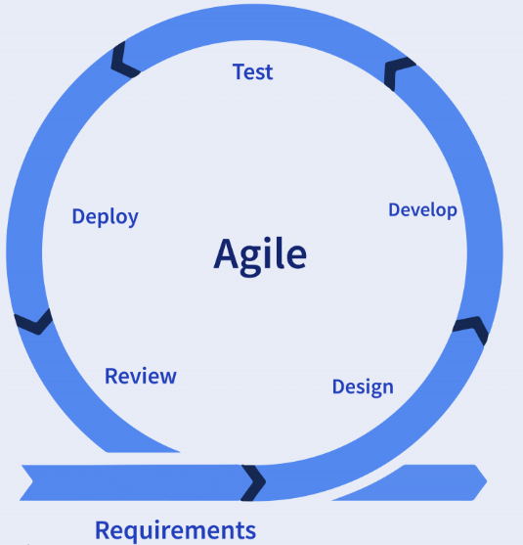

**Phase-1:** Requirements: - In this phase, we gather data and analyze how website selling technology productss works. Also collected requirements after reviewing earlier papers & websites.

**Phase-2**: Design: - On the basis of gathered information we designed and built a model.

**Phase-3:** Development: - Deliver the working software based on iteration, requirements or feedback.

**Phase-4:** Test: - This is a testing phase where we test our model.

**Phase-5:** Deployment: - In this phase we deploy our final release of the iteration into production.

**Phase-6:** Review: - Receiving feedback on the product and working through it.

# **Snapshots:**

**Login page**

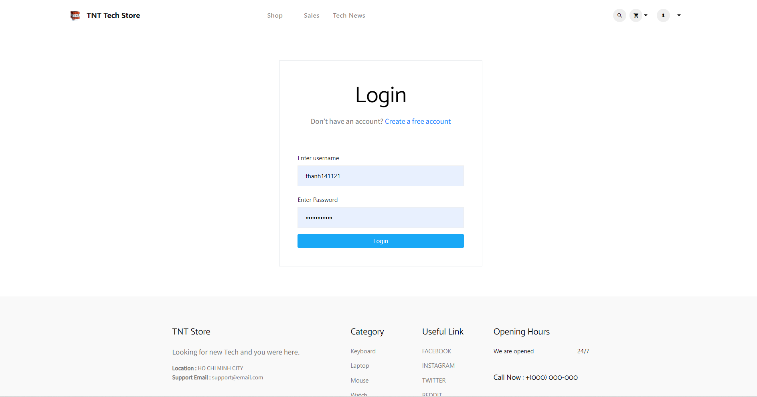

**Register page**

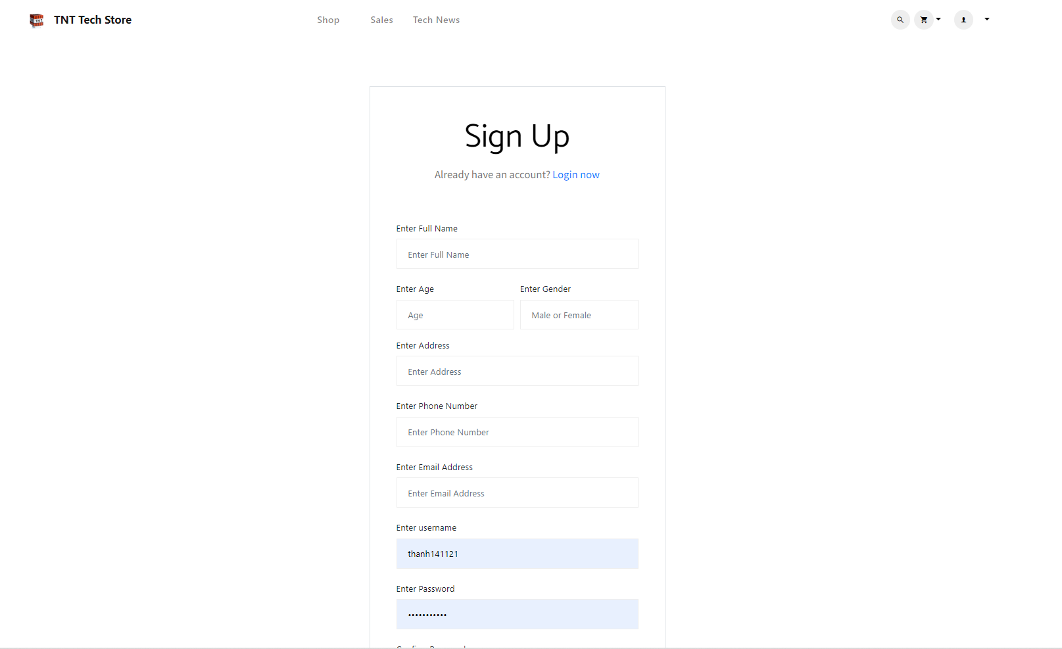

**Main Page**

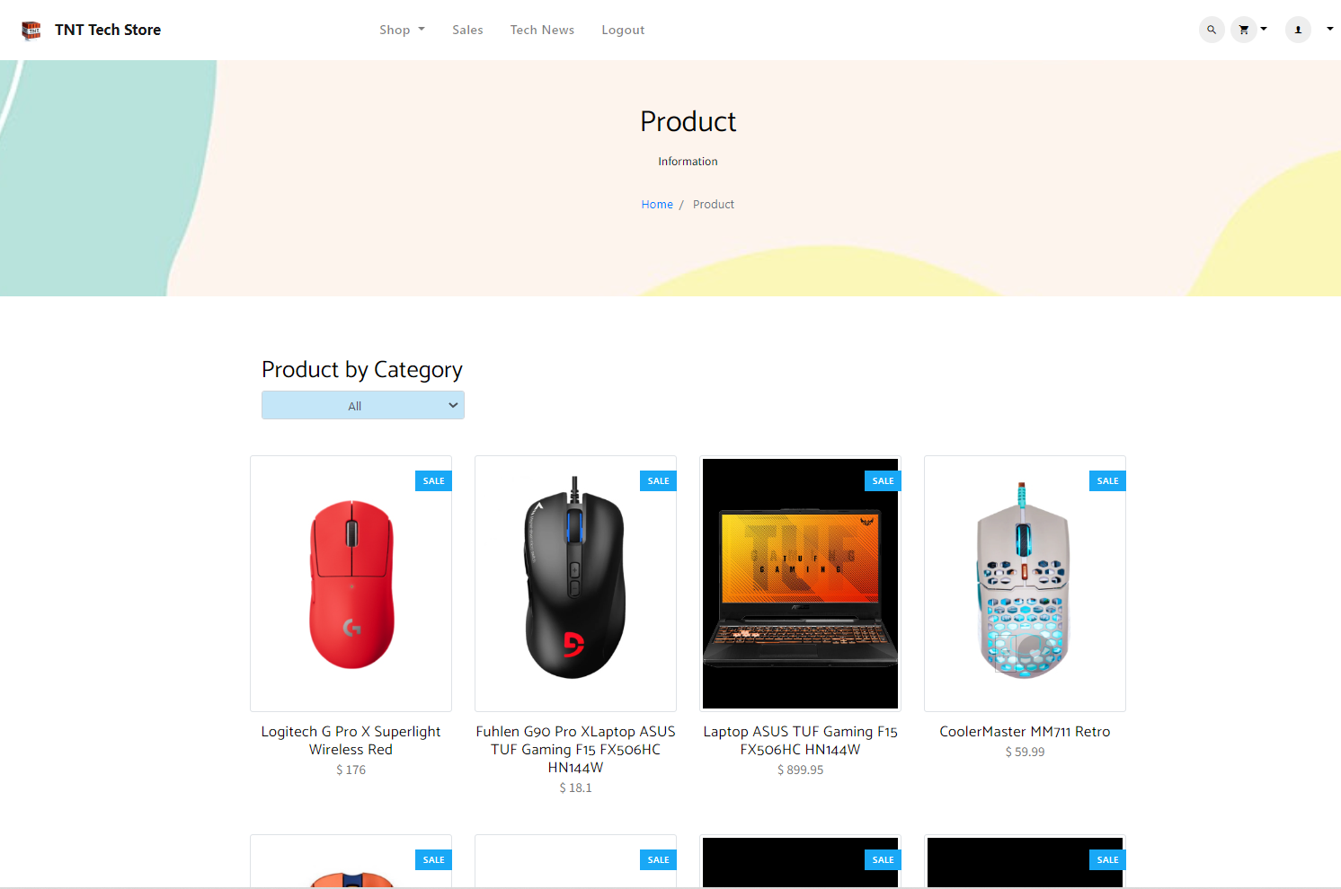

**View product by category**

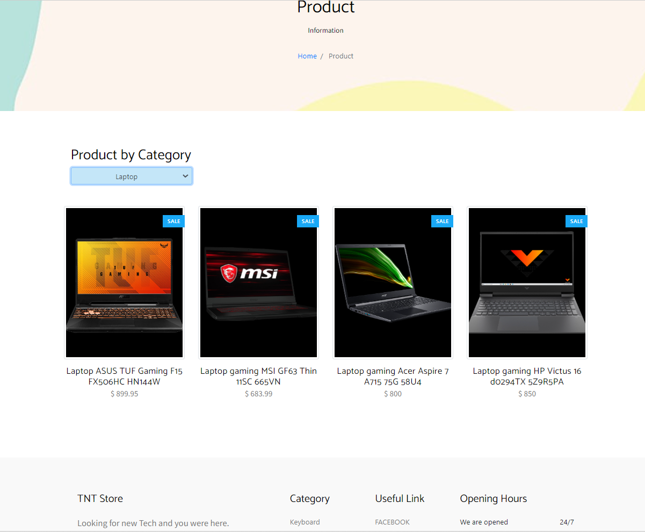

**Product Detail**

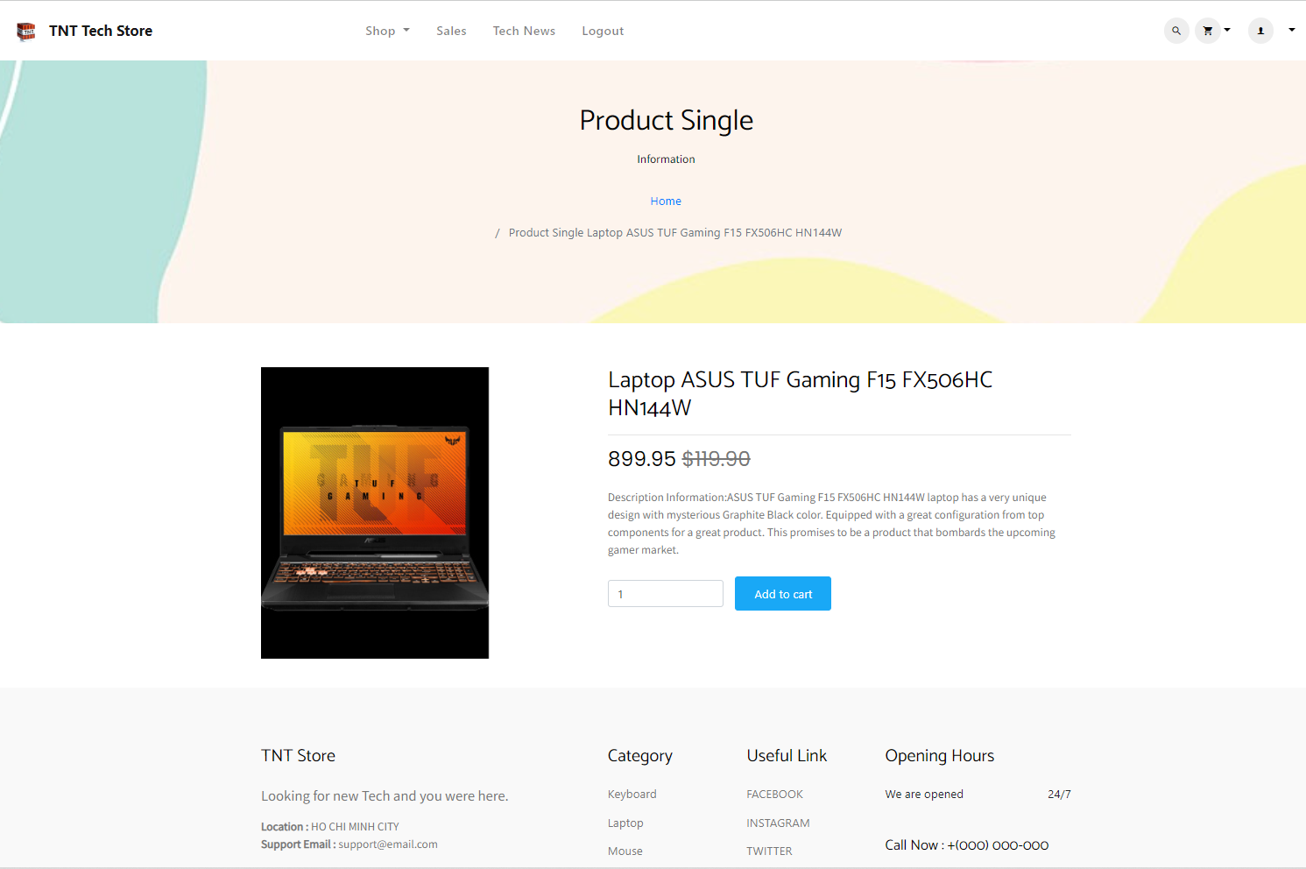

**Mini Cart**

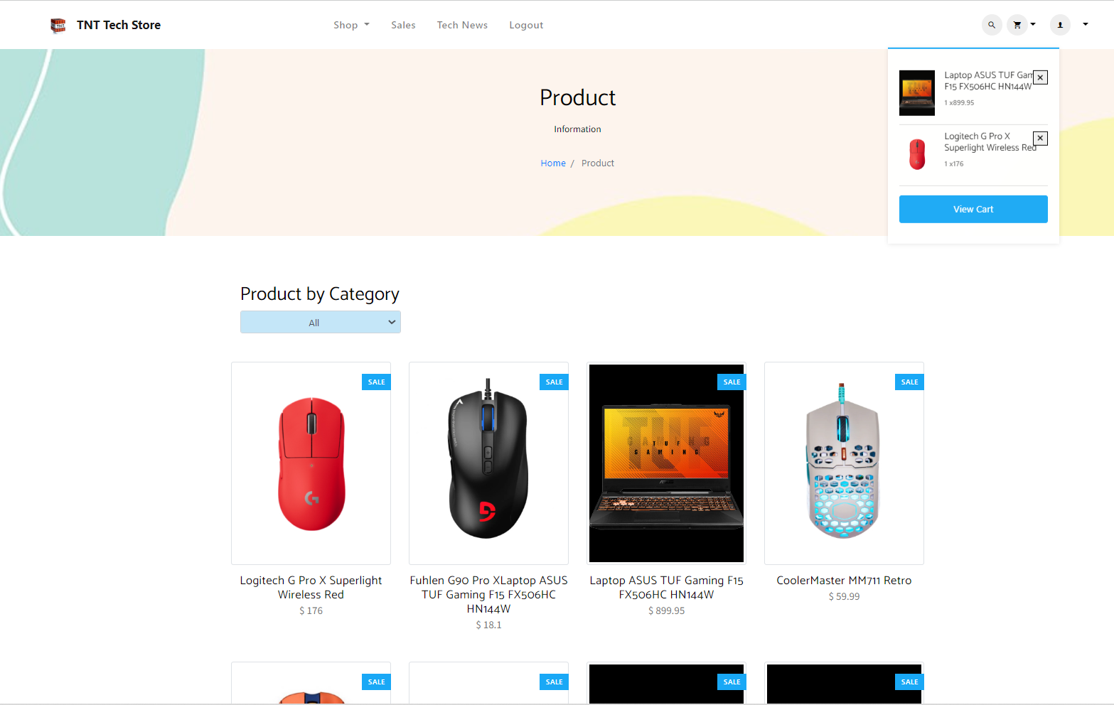

**Cart Page**

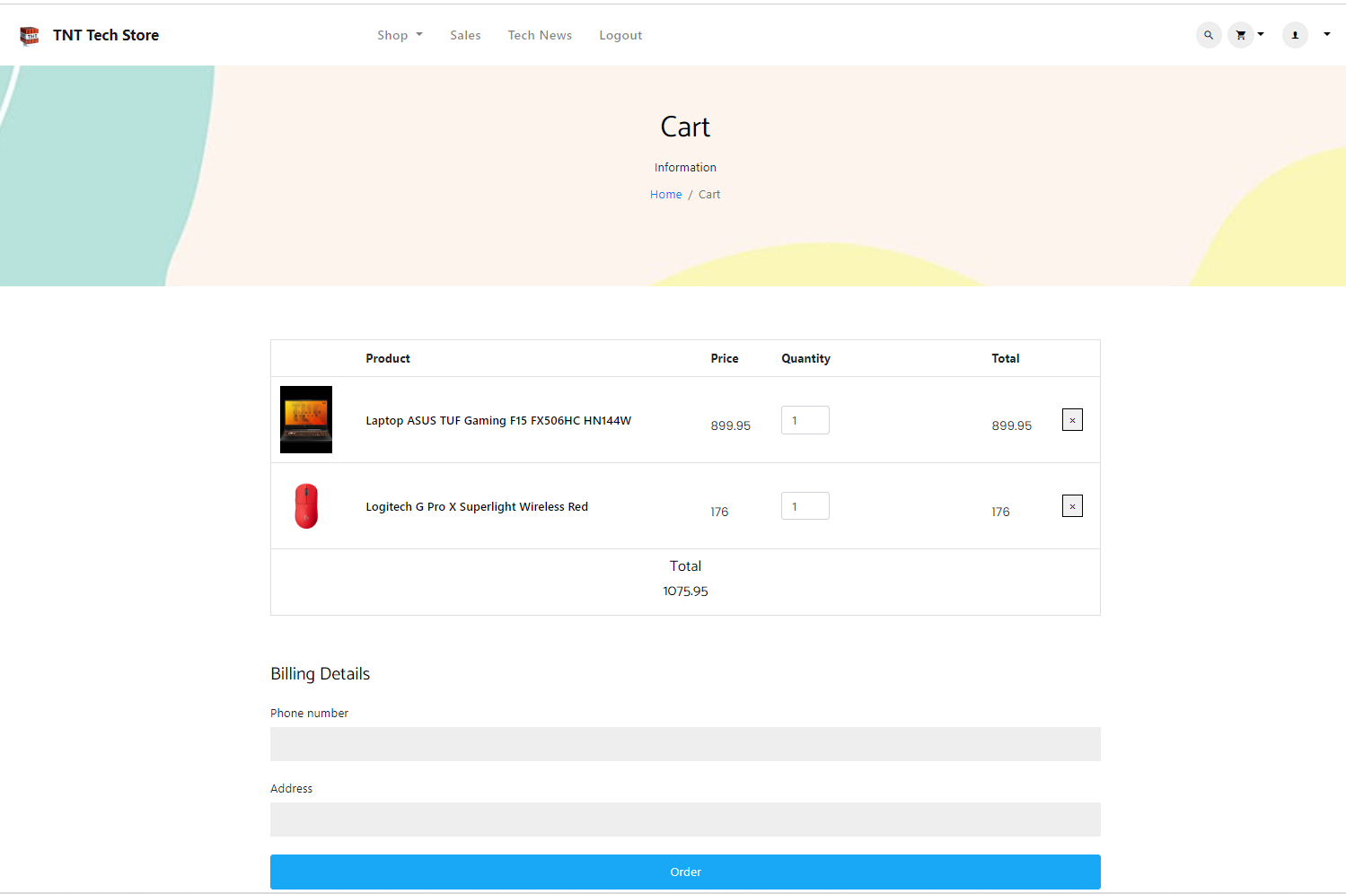

**Order Page**

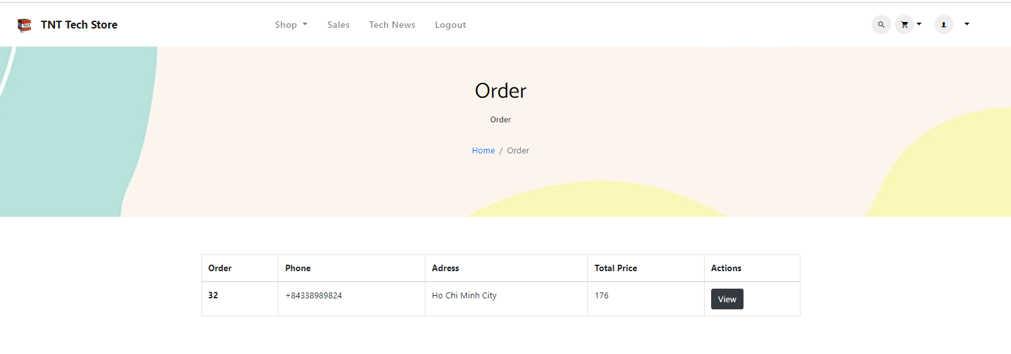

**Order Detail**

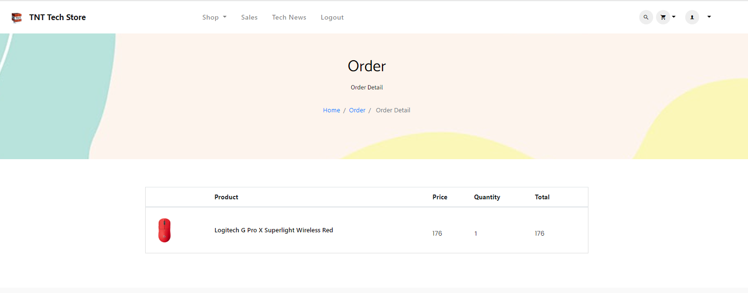

**Admin Page(Role:Admin)**

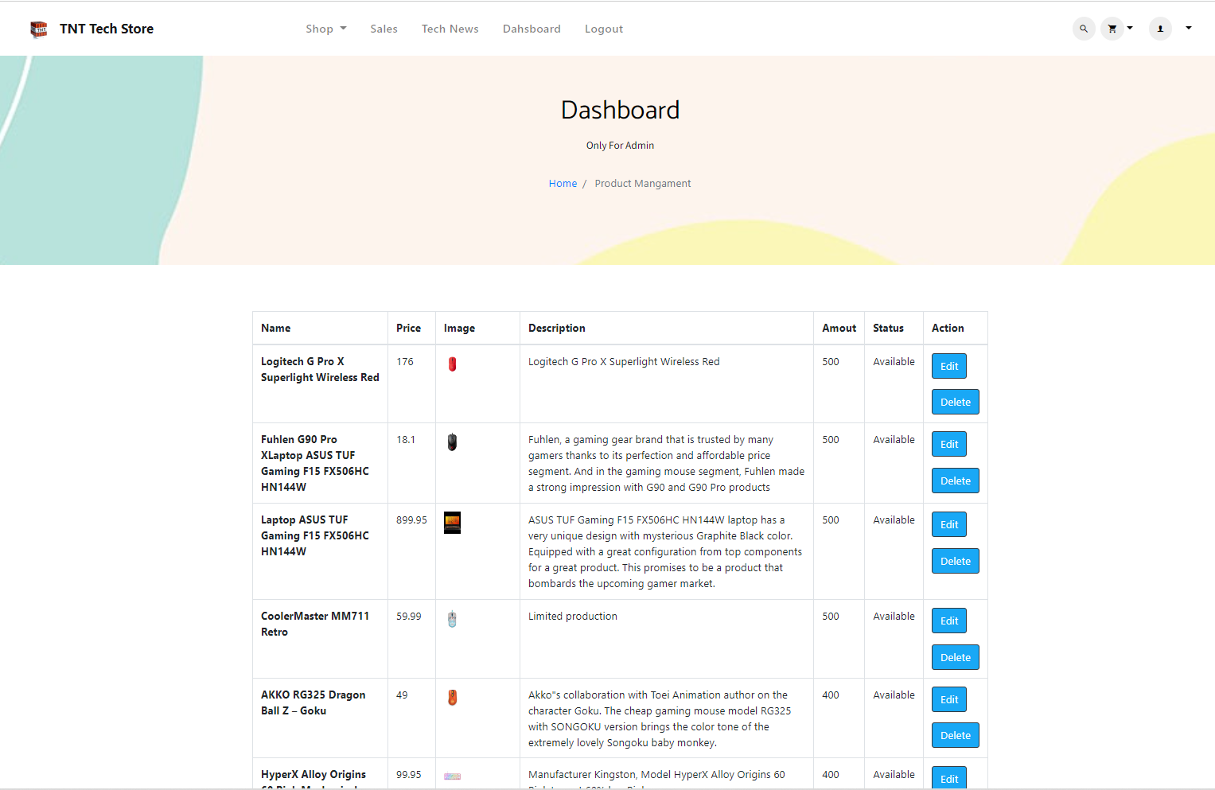

**Add Product**

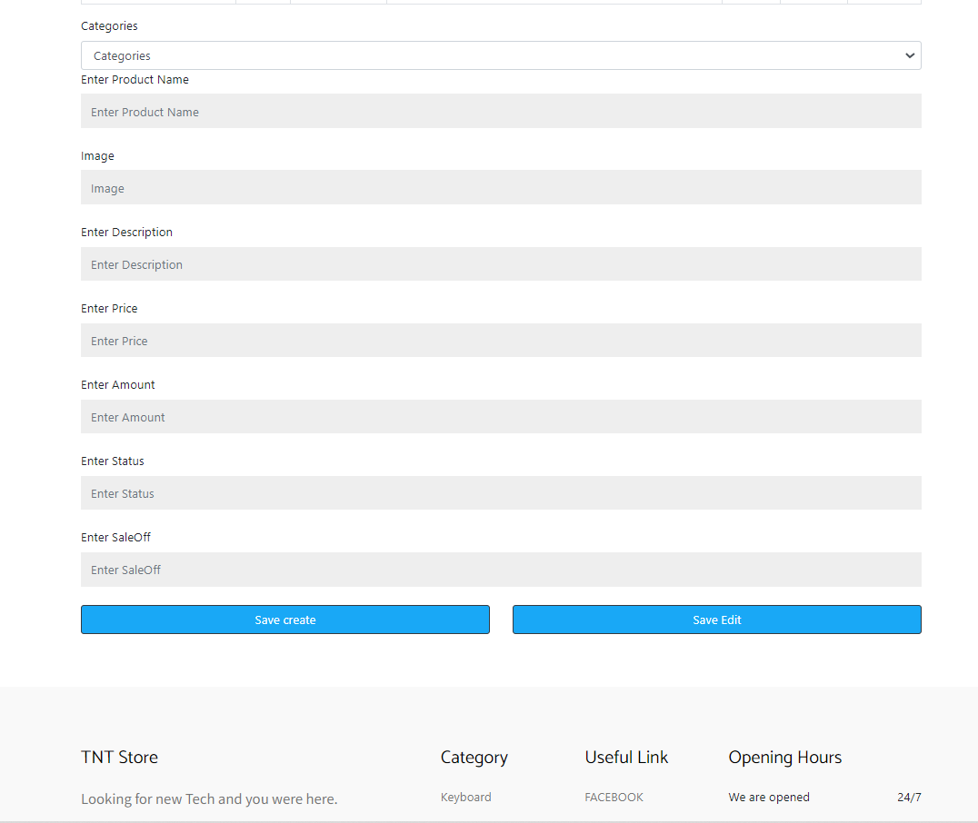

**Edit Product**

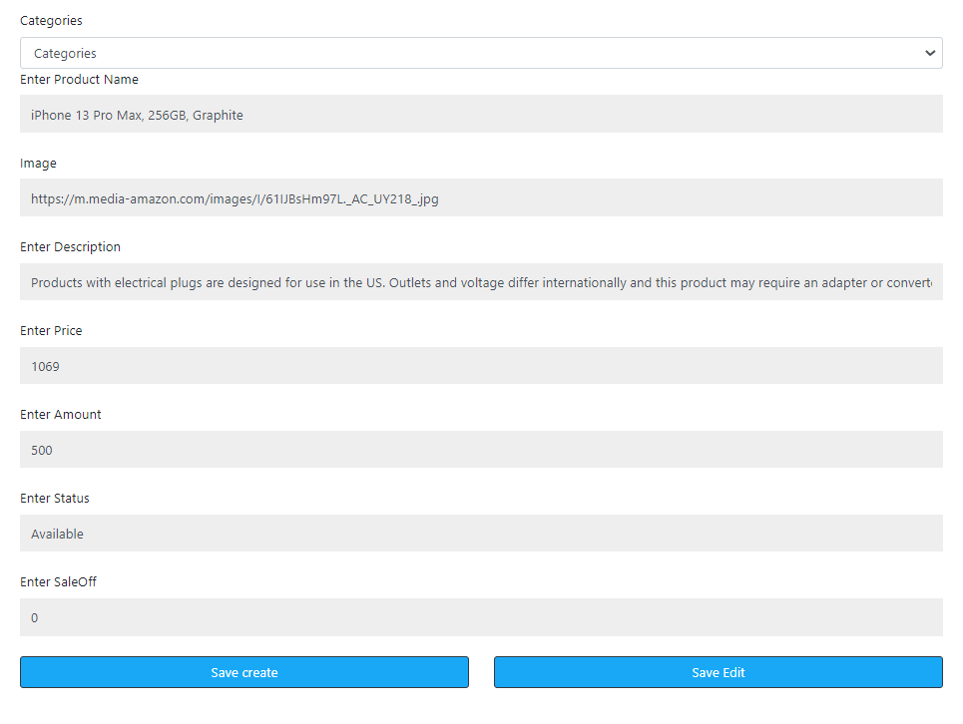

# **11. Use Case Model:**

**11.1. View Technology products Info:**

|  |  |
| --- | --- |
| Brief Description | This use case describes how user view products information |
| Basic Flow | 1. Click on the product that the user want to see its detail |
| Alternate Flow |  |
| Validation |  |
| Pre-Conditions | User should have internet access and browser with latest updates. |
| Post-Conditions | Display technology products information. |

**11.2. Add product to Cart:**

|  |  |
| --- | --- |
| Brief Description | This use case describes how user add products to cart |
| Basic Flow | 1. Select technology products  2. Click “Add to cart” |
| Alternate Flow |  |
| Validation |  |
| Pre-Conditions | User should have network access and Browser with latest updates. |
| Post-Conditions | The shopping cart has the technology product that user have just added. |

**11.3. Delete products in Cart:**

|  |  |
| --- | --- |
| Brief Description | This use case describes how user delete products to cart |
| Basic Flow | 1. Select technology products to remove from the cart  2. Click remove |
| Alternate Flow |  |
| Validation |  |
| Pre-Conditions | User should have network access and Browser with latest updates.  There are products in the cart |
| Post-Conditions | The technology products disappeared from the cart |

**11.4. Order product:**

|  |  |
| --- | --- |
| Brief Description | This use case describes how user pay cart |
| Basic Flow | 1. Select view cart  2. Fill in the address  3. Click “Order” |
| Alternate Flow |  |
| Validation |  |
| Pre-Conditions | User should have network access and Browser with latest updates.  User have already logged in  There are products in the cart |
| Post-Conditions | Shopping cart is stored down database |

**11.5. View Order history:**

|  |  |
| --- | --- |
| Brief Description | This use case describes how user view order history |
| Basic Flow | 1. Select Order page. |
| Alternate Flow | The system will validate the user. If the user does not have an order, nothing will be displayed |
| Validation | User’s order |
| Pre-Conditions | User should have network access and Browser with latest updates.  User have already logged in |
| Post-Conditions | Show a list of order made by user |

**11.6. View order detail:**

|  |  |
| --- | --- |
| Brief Description | This use case describes how user view order detail |
| Basic Flow | 1. Select Order page.  2. Select order that user wants to see the detail.  3. Click “View” |
| Alternate Flow | The system will validate the user. If the user does not have an order, nothing will be displayed in Flow 1 |
| Validation | User’s order |
| Pre-Conditions | User should have network access and Browser with latest updates.  User have already logged in |
| Post-Conditions | Show the detail of order made by user |

**11.6. Add products(Admin Role):**

|  |  |
| --- | --- |
| Brief Description | This use case describes how admin add a new technology product |
| Basic Flow | 1. Select Insert  2. Fill in the full detail of the technology product  3. Click “Save create” |
| Alternate Flow | 1. The system will validate the information provided. If any invalid data is found, the input form will be redirected with an error message. |
| Validation | Details of technology products.  Details must be valid. |
| Pre-Conditions | Admin should have network access and Browser with latest updates.  Admin has already logged in |
| Post-Conditions | Success popup will be shown after create successfully. |

**11.7. Edit Product(Admin Role):**

|  |  |
| --- | --- |
| Brief Description | This use case describes how admin edit a technology product |
| Basic Flow | 1. Select product that admin wants to edit  2. Click “edit”  2. Edit the details  3. Click “Save edit” |
| Alternate Flow | 1. The system will validate the information provided. If any invalid data is found, the input form will be redirected with an error message. |
| Validation | Details must be valid. |
| Pre-Conditions | Admin should have network access and Browser with latest updates.  Admin has already logged in |
| Post-Conditions | Success popup will be shown after edit successfully. |

# **12. Data Flow Diagram**

A data flow diagram (DFD) maps out the flow of information for any process or system. It uses defined symbols like rectangles, circles and arrows, plus short text labels, to show data inputs, outputs, storage points and the routes between each destination.

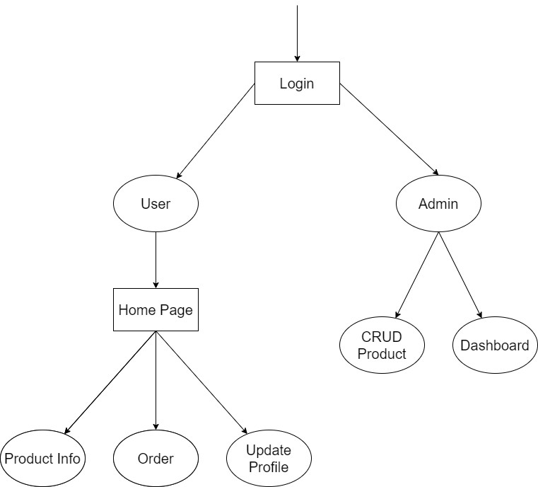

# **13. Use Case Diagram**

A use case diagram is a graphical depiction of a user's possible interactions with a system. A use case diagram shows various use cases and different types of users the system has and will often be accompanied by other types of diagrams as well. The use cases are represented by either circles or ellipses. The actors are often shown as stick figures.

